Notes

This information was presented at the last meeting of the scientific committee of Chilean hake (22/10/2022). The age composition from the acoustic survey showed an increase in the adult fraction. However, the stock assessment model is set from age 2 to 12+. I began the task to get the historic age composition (survey) to improve the model. Furthermore, I started the reconstruction of fishery age composition. The objective is to set the model from age 0 to 14+

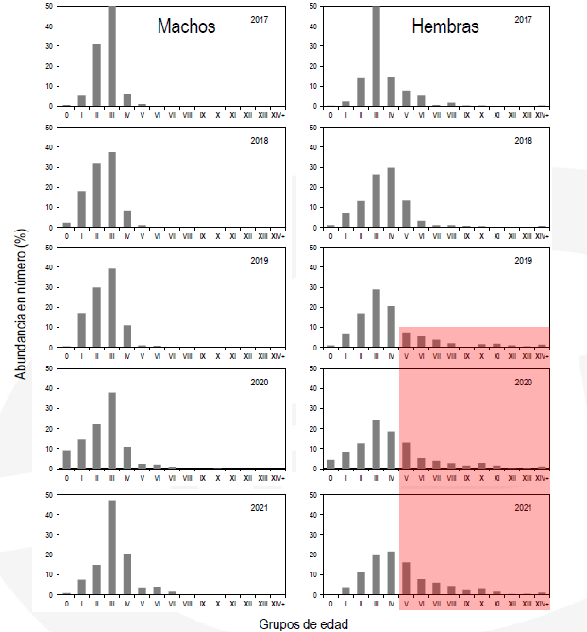

Figure. Acoustic age composition, abundance in number.-

Stock assessment from government agency (IFOP, [www.ifop](http://www.ifop).cl)

In relation with the Chilean hake assessment the model from Ifop, does not consider fleets (sums catches and composition. Additionally, use a time series of catches from 1940 and age composition with information from 1970. In the case of Inpesca model, our information began in 1992. The interesting point is that this model has the same problem to fit the acoustic biomass, maybe is worst than the fit in the model by fleet of Inpesca.

